Experiment 6:

* Aim: Implementation of a Router Using Packet Tracer
* Apparatus (Software):
* Cisco Packet Tracer: For network simulation.
* Command Prompt: For executing basic network commands like `ping` and `ipconfig`.
* Procedure:
* Below are the step-by-step instructions to implement a router using Packet Tracer:
* Step 1: Launch Packet Tracer
* Open Cisco Packet Tracer on your computer.
* Start a new project by clicking on File > New
* Step 2: Add Devices to the Workspace
* Router: From the device type list, select the Router category and choose a router model (e.g., 1841). Drag and drop it into the workspace.
* Switches: Add switches to connect to the router, if needed.
* End Devices:Select and drag PCs (e.g., PC-PT) into the workspace. These devices will be connected to the router via switches.

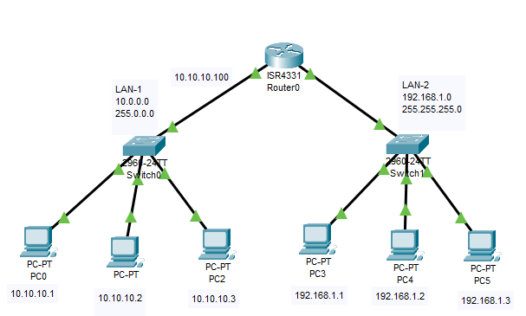

* Step 3: Connect Devices
* Use the Connections icon to choose appropriate cables:
* Straight-Through Cable to connect PCs to switches.
* Cross-Over Cable to connect switches to the router.
* Connect each PC to a switch by selecting FastEthernet ports.
* Connect the switches to the router using the appropriate GigabitEthernet interfaces.



* Step 4: Configure IP Addresses
  + Click on each PC and navigate to the Desktoptab.
  + Open the IP Configurationtool.
  + Assign an IP address and subnet mask to each PC. For example:
  + PC0: IP Address: 10.10.10.1 Subnet Mask: 255.0.0.0
  + PC1: IP Address: 10.10.10.2 Subnet Mask: 255.0.0.0
  + PC2: IP Address: 10.10.10.3 Subnet Mask: 255.0.0.0
  + PC3: IP Address: 192.168.1.1 Subnet Mask: 255.255.255.0
  + PC4: IP Address: 192.168.1.2 Subnet Mask: 255.255.255.0
  + PC5: IP Address: 192.168.1.3 Subnet Mask: 255.255.255.0

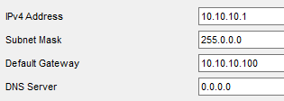

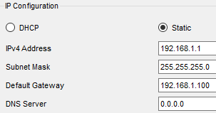

* Step 5: Configure the Router
* Click on the router to open its configuration window.
* Go to the CLI tab to configure the router interfaces and assign IP addresses.

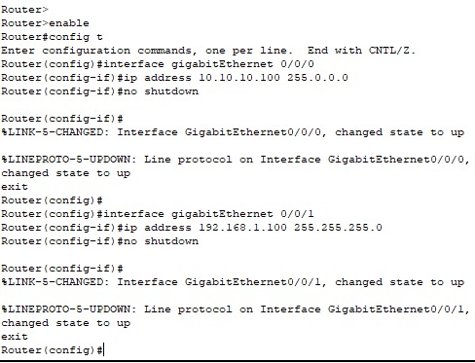

* Step 6: Verify Physical Layer Connectivity
  + Switch to Simulation mode (bottom right)
  + Add a Simple PDU from the Add Simple PDU (envelope icon) tool and click on one PC and then on another PC on a different network. This will generate a ping command.
  + Run the simulation to ensure the PCs are physically connected and that the router forwards packets between networks.

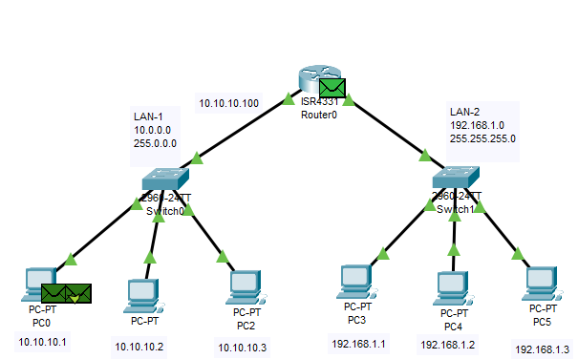

* Step 7: Test Network Connectivity
* Switch back to Real-Time mode.
* Open the Command Prompt on each PC by going to Desktop > Command Prompt
* Use the`ping command to test the network connection between PCs across different networks. For example:
* On PC0, type: ping 192.168.1.3

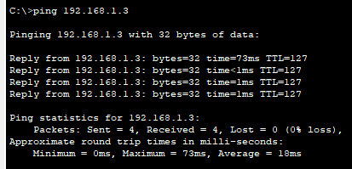

* Step 8: Observe Router Operation
* Notice how the router forwards packets only to the correct destination network, based on IP addresses.
* The router uses routing tables to direct traffic, ensuring efficient network management.

